Project Design Phase-II
Technology Stack (Architecture & Stack)

Date | 02 October 2026
Team ID | SWTID-2026-8115
Project Name
Maximum Marks | 4 Marks

Technical Architecture:
Auto Ticket Classification using Flow Designer uses a new support ticket to trigger a workflow. Configured conditions classify and route a matching ticket; agents can review tickets that do not match.
Architecture overview: ticket submission, classification, and routing
Reference: ServiceNow Flow Designer documentation
Guidelines:
Include all the processes (As an application logic / Technology Block)
Provide infrastructural demarcation (Local / Cloud)
Indicate external interfaces (third party API’s etc.)
Indicate Data Storage components / services
Indicate interface to machine learning models (if applicable)
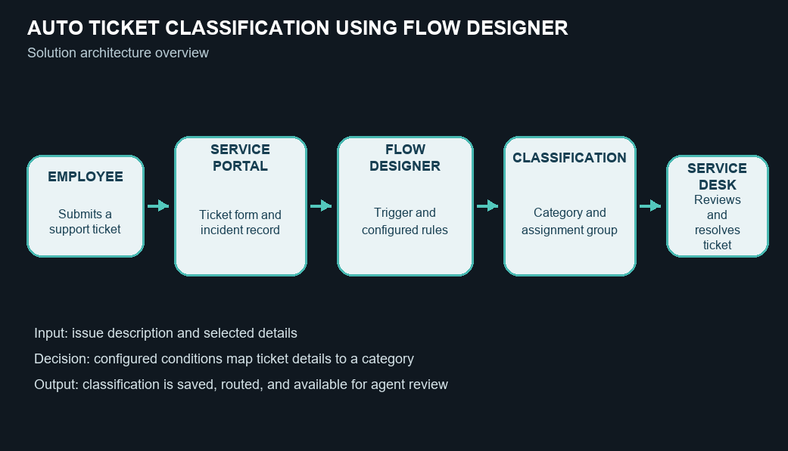

Table-1 : Components & Technologies:
S.No | Component | Description | Technology
- 1 | User Interface | Employee ticket form and service desk incident views. | ServiceNow portal / incident form
- 2 | Application Logic - 1 | Starts the process when a new ticket is created. | ServiceNow Flow Designer record trigger
- 3 | Application Logic - 2 | Checks ticket details against configured decision conditions. | Flow Designer conditions and flow logic
- 4 | Application Logic - 3 | Writes the classification and routes a matched ticket. | Flow Designer record update actions
- 5 | Database | Stores incidents, descriptions, categories, assignment groups, and status. | ServiceNow incident records
- 6 | Cloud Database | Platform-managed storage for application records. | ServiceNow platform data layer
- 7 | File Storage | Stores ticket attachments when used by the instance. | Platform-managed attachment storage
- 8 | External API - 1 | No external API is required in the proposed design. | Not used
- 9 | External API - 2 | No external API is required in the proposed design. | Not used
- 10 | Machine Learning Model | Classification uses configured rules; no machine-learning model is included. | Not used
- 11 | Infrastructure (Server / Cloud) | Runs within the configured ServiceNow instance; no separate custom server is planned. | ServiceNow platform instance

Table-2: Application Characteristics:
S.No | Characteristics | Description | Technology
- 1 | Open-Source Frameworks | No open-source framework is required for this platform-based design. | Not applicable
- 2 | Security Implementations | Use role-based access and platform access controls for tickets and flow configuration. | ServiceNow roles and ACLs
- 3 | Scalable Architecture | The workflow uses a record trigger and configurable conditions within the platform. | ServiceNow Flow Designer
- 4 | Availability | The application runs on the configured ServiceNow instance; availability follows that instance. | ServiceNow platform
- 5 | Performance | Use focused trigger conditions and a small set of decision rules to avoid unnecessary runs. | Flow Designer trigger and conditions

References:
https://www.servicenow.com/docs/r/build-workflows/workflow-studio/getting-started-flow.html
https://www.servicenow.com/docs/r/build-workflows/workflow-studio/flow-designer-arch-overview.html
https://www.servicenow.com/docs/r/build-workflows/workflow-studio/flow-triggers.html
https://www.servicenow.com/docs/r/it-service-management/incident-management/r_CategorizingIncidents.html?contentId=157WlDlV609K5X5o7pEd8A
https://www.servicenow.com/docs/r/it-service-management/incident-management/t_DefinAnAssignRuleIncidents.html

